**Raising and Lowering the Magnet Using Duff-Norton Control Box**

Yufan Xu

Spinlab

6/5/2018

**Abstract**

Procedure to use the Magnet Lifting System has been well introduced in Alex Grannan’s thesis; this article mainly focuses on Alex’s description and some electrical troubleshooting tips to assist users with the operation.

**Procedure to Raise or Lower the Magnet**

Quote from Alex Grannan’s thesis:

*“Before performing the below steps for raising and lowering the magnet, it may be necessary to redistribute any build-up of grease to the threads in order to provide adequate lubrication during movement. Also make sure that the RoMag convection tank is level and that the threaded rods used to hold the convection tank together are centered so that the magnet is not scratched or gouged during the raising and lowering process…”*

Pay extra attention to the keys of the shafts which could be dangerous once they become loose and fall out. They should be taped done well. The standard procedure for lifting and lowering the magnet was also written in Alex’s thesis.

*“…*

1. *Locate the lab's fuse box and move the circuit breaker labeled ‘Duff-Norton.’ Move to the ‘ON’ position.*
2. *Move to the Duff-Norton box, and rotate the large knob to give power to the Duff-Norton system.*
3. *Press the button labeled ‘Raise’ or ‘Lower’. Make certain that all the acme threads are rotating. As the magnet is moving downwards, inspect the experimental components on the convection tanks (wires, pipes, etc.) and ensure that they are not obstructing the magnet's path. Light contact of the magnet with insulation or plastic wrap is acceptable.*
4. *The magnet has an upper and lower limit and will stop automatically when these positions are reached.*
5. *When experimentation is complete, push the ‘Raise’ button to lift the magnet to its original position. It will automatically stop at the top…”*

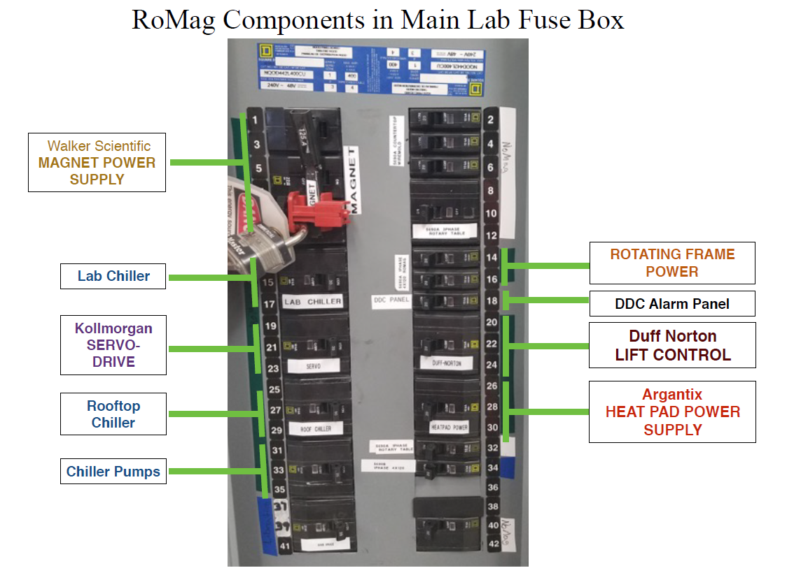Fig 1. Lift Control Component in Main Lab Fuse Box (From Alex’s thesis). Duff Norton fuse switch is located at the right middle inside of the main fuse box.

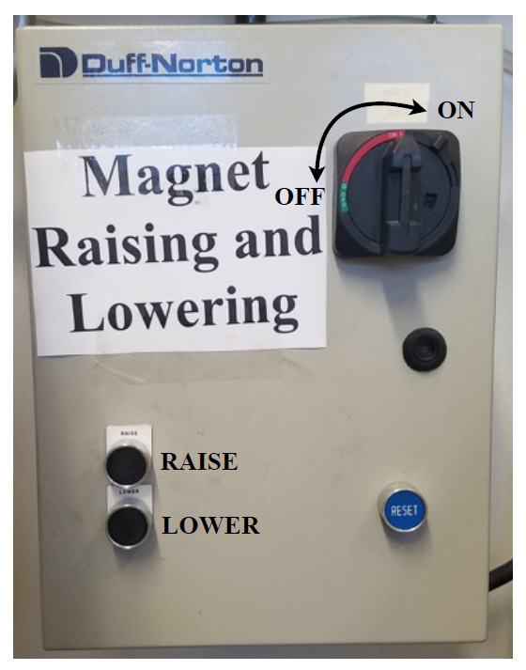

Fig 2. The front panel of the Duff-Norton, located near the lab chiller (From Alex’s thesis).

**Electrical Troubleshooting**

In June 2018, we encountered an issue with the Duff-Norton Lift Control. Upon hitting the raise or lower button, the motor did not respond. Further investigation suggested that the reset button was not in the proper status. After fixing the problem, we decided to come up with the analysis procedure below.

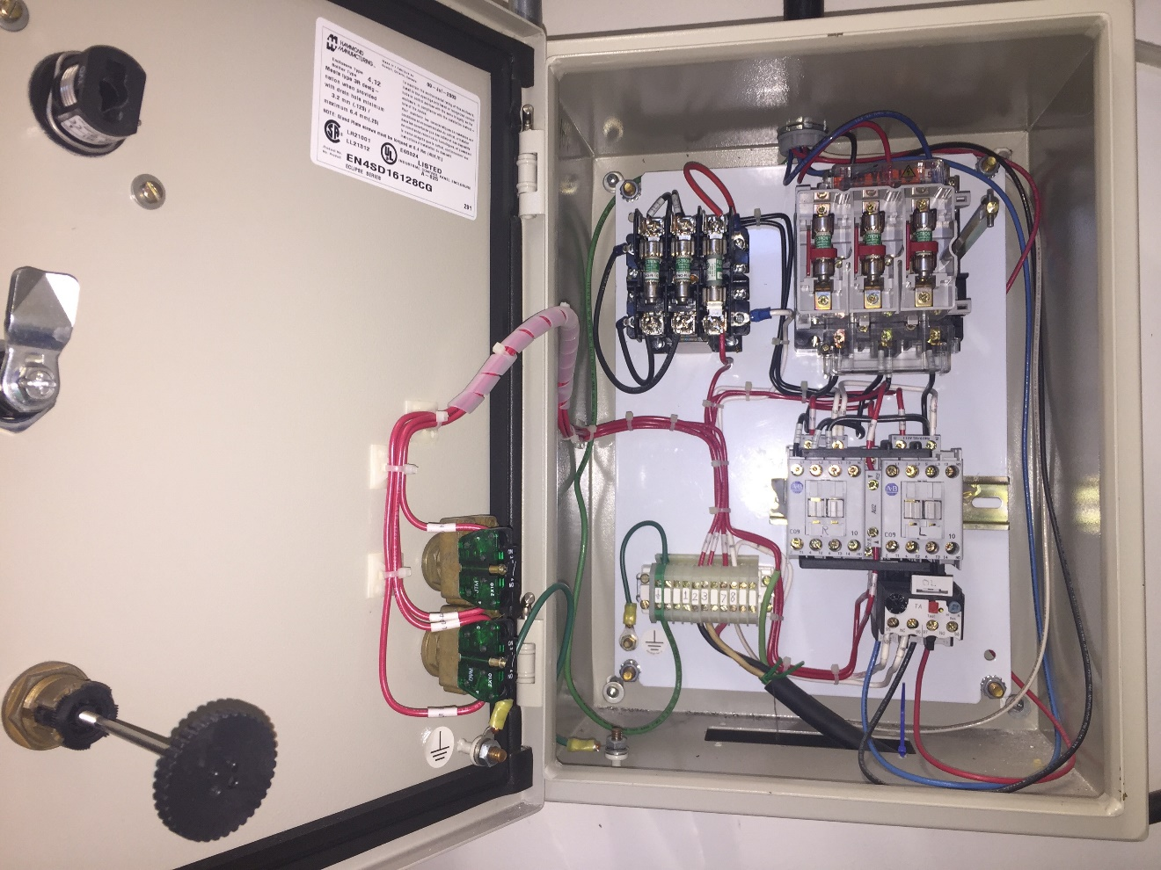

**Overload Reset**

**220V 3-phase Outlet**

**220V 3-phase Inlet**

**L/R Switches**

**Reset Pusher**

**Input Fuse Box**

**Relays Lower (L) Raise (R)**

**Output Fuse Box**

**Main Switch**

Figure 2. An overview of the inside of the control box.

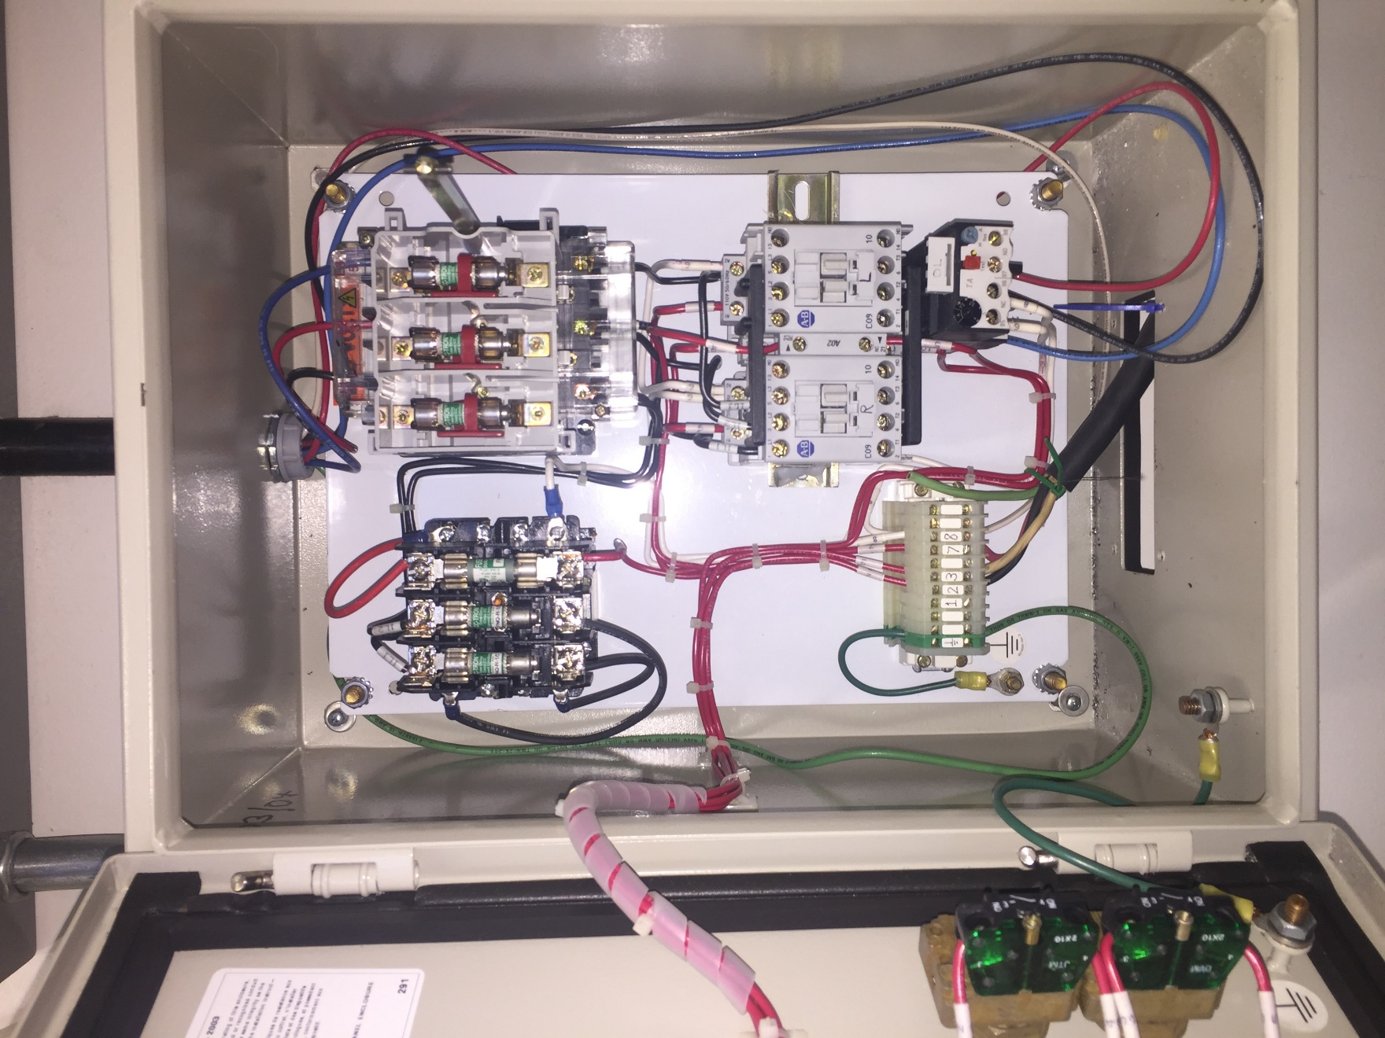

**Relay Lower (L)**

**Relay Raise (R)**

2

1

Figure 3. An overview of the circuit of the control box.

Symptom 1: when pressing the Lowering/Raising bottom, the motor does not respond.

1. Turn off the Duff-Norton switch in the main fuse box. Open the control box panel and visually check if there is any fuse blown. If so, replace them.
2. Make sure the yellow reset bottom (shown in figure 4) is pushed in.
3. Turn on the Duff-Norton switch in the main fuse box. Press the raise/lower bottom and see if it is working. If not, then proceed with caution and check the voltages across the inlet. The voltage difference should be ~200V between each pin (locate at position “1” in figure 3). If there’s no voltage, it most likely means the issue is at the main fuse box.
4. Check the voltage across the outlet at position “2”. When pressing the lifting bottoms, the voltage difference between each lug should be ~200V. If the problem persists, the control box is working fine, but the connections to the motor or inside of the motor may be bad.
5. Turn off the main switch in the main fuse box and check the resistance of the fuses with a multi-meter. If there is a broken one, replace it. Check the connection of the wires and lugs as well.
6. If all the components work fine, but the issue persists, turn on the main switch from the main fuse box and check the conductivity of the relay. Proceed with caution and press the middle part of the relay with a screwdriver (or finger, but not recommended, shown in the figure below), the relay should get a response and lower/raise the magnet accordingly. If not, there is an issue with the relay.

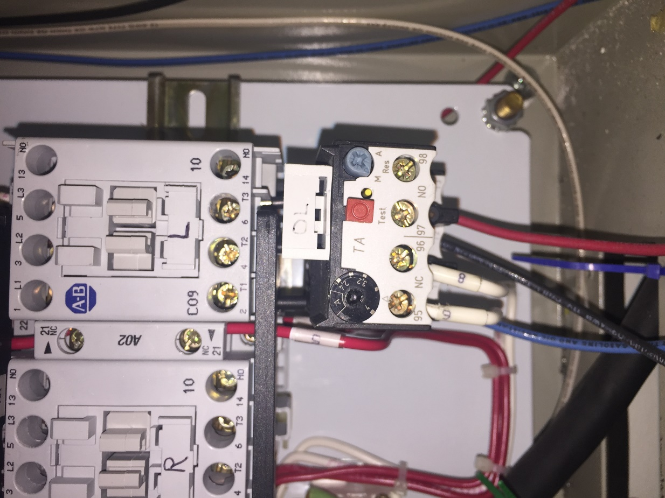

This yellow reset bottom should be pushed and stay inward

Figure 4. The reset component is most likely to cause the issue.

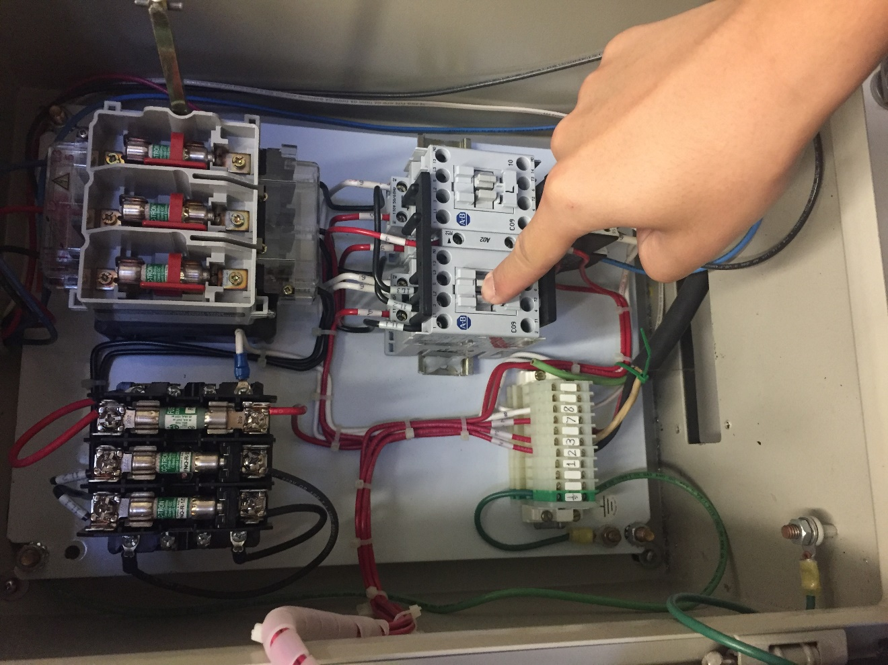

Figure 5. Test the relay with caution (and courage).